We can connect the datasource using rest API with dashboard designer, please find the following steps for the successful connection. The REST API in dashboard support the json output.
- Login with dashboard designer and create new REST API datasource.
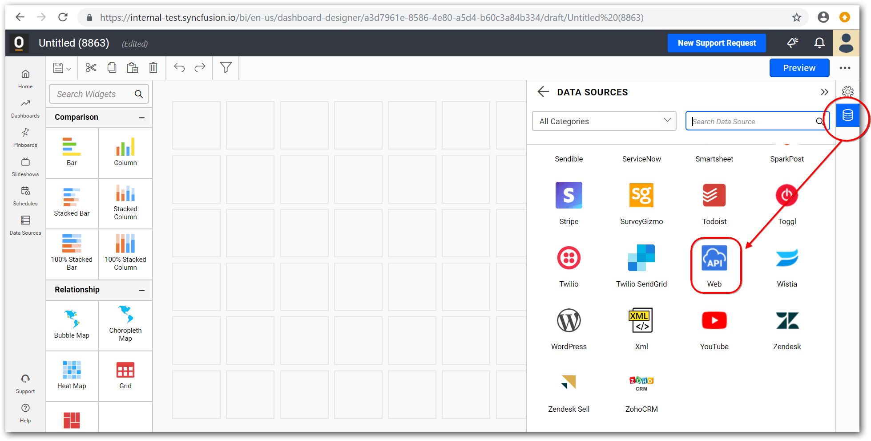

- Give the elastic search endpoint along with the database with document endpoint.
http://my_elastic_host:9200/{dbName}/{tableName}/_search . make sure we have only use the single table in REST API.
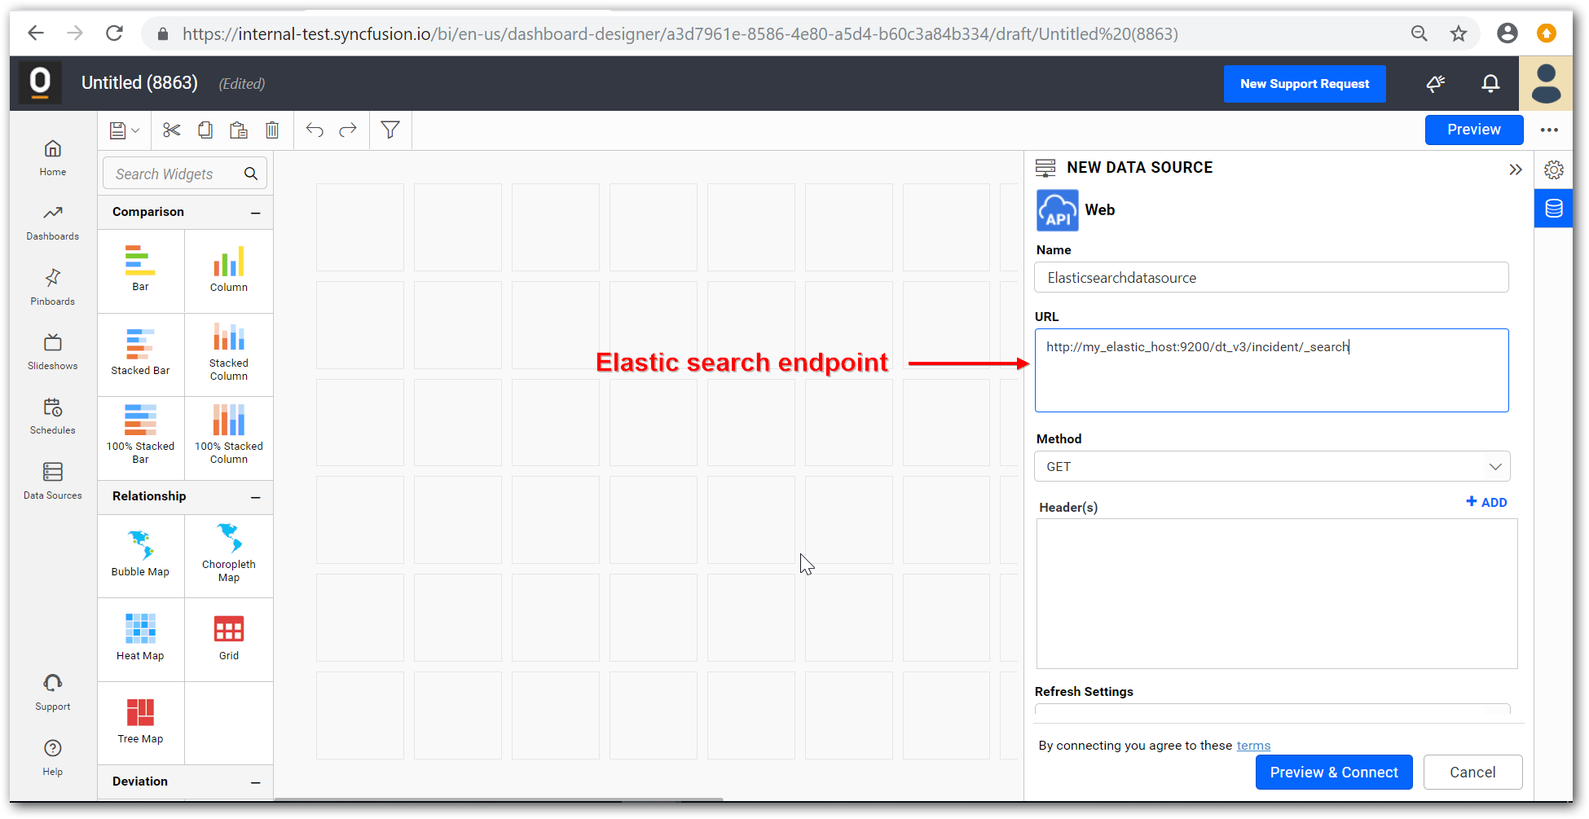
- Currently it supports the Elastic search native authentication, if the server is configured with native authentication select authentication in datasource window as basic http authentication and give the credentials in the respective fields.
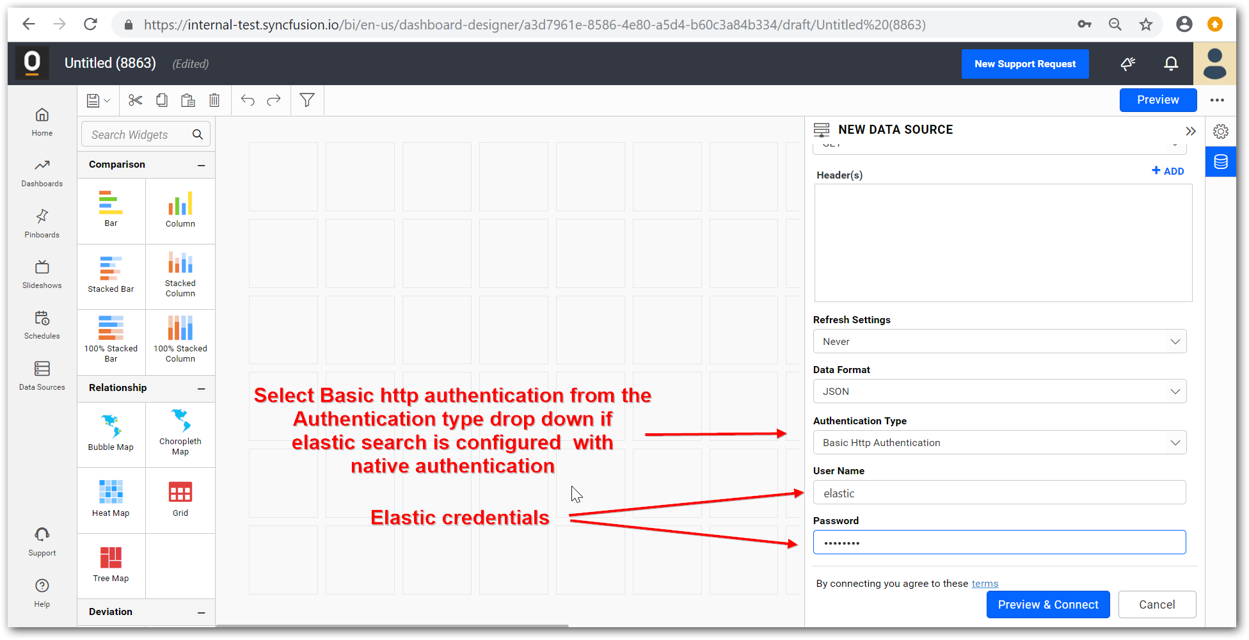

- For the GET Method we can get the whole records from the given end point, we can also give the DSL queries (https://www.elastic.co/guide/en/elasticsearch/reference/current/query-dsl.html) which is supported by the elastic search. For that we must set the method as POST and we can give the DSL queries as RAW format.
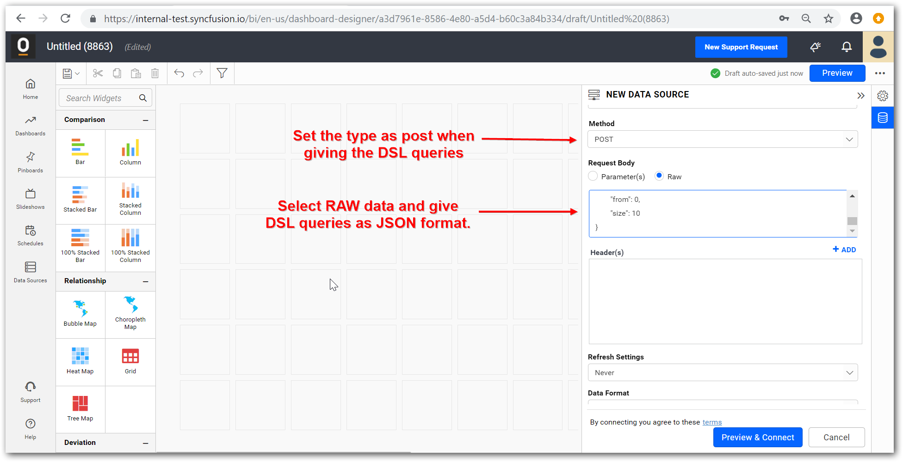
The given query above given is simple query for paginating the records which is given below,
{
"query":
{
"match_all":
{}
},
"from": 0,
"size": 10
}

- After given the details click preview & connect, in this data will be previewed with the first 10 rows of the given endpoint. You can select or unselect columns you want. Once it done click connect to move on to the dashboard.
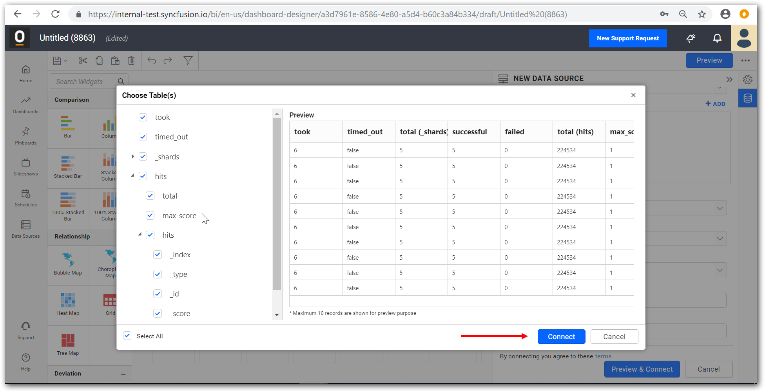
- After connecting to the datasource drag and drop the table you are going to use from the left side panel. Once again, the preview will be show in the bottom preview window. Save the datasource to used it on the dashboard.
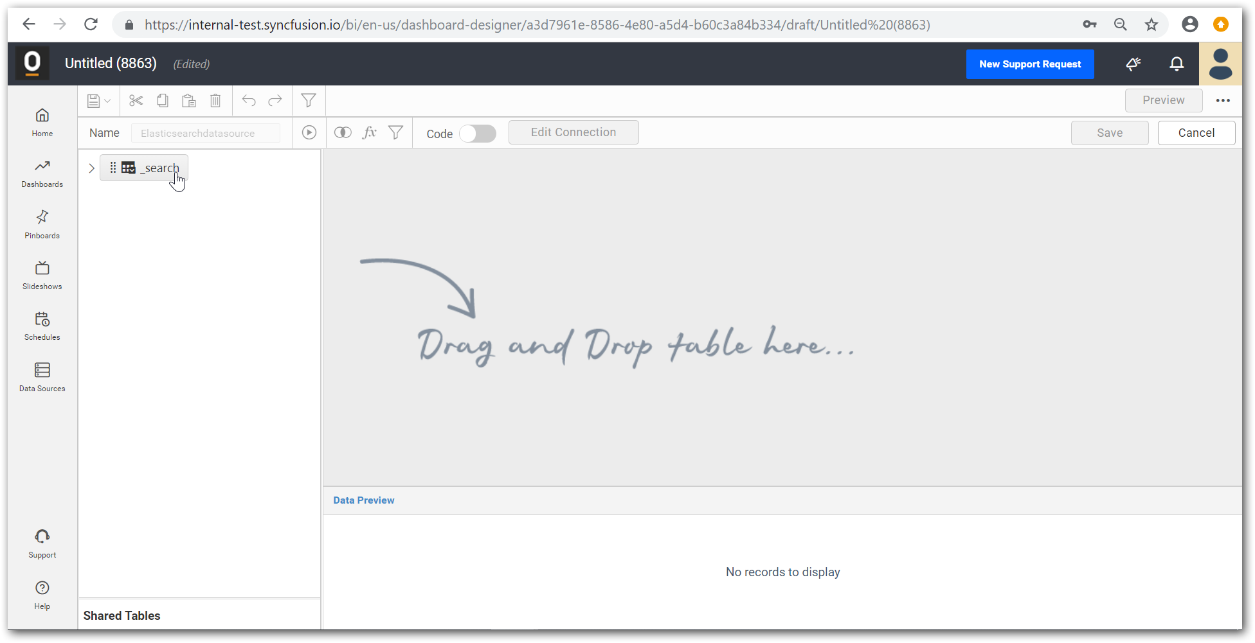
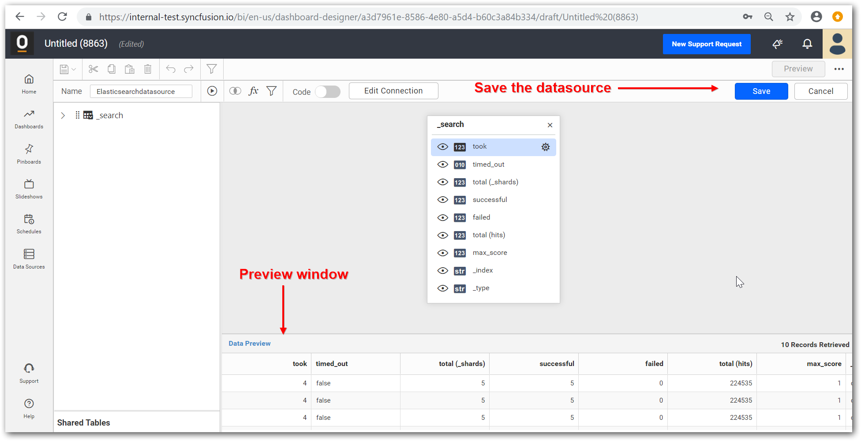
- After that you will moved to the designer page where you can select the widget you want and exhibit your elastic search data on that as like the following steps.
