Integrate the ASP.NET MVC application with UMS
Prerequisite:
- Create a ASP.NET MVC application.
- Add the created MVC application as an application in the UMS by following in the below help documentation,
https://help.syncfusion.com/user-management-server/application/manage-applications#add-new-application
- Client Id and Client Secret will be generated for created application and you can get it by following the below documentation,
https://help.syncfusion.com/user-management-server/application/manage-applications#view-application
Process:
- Include the installed UMS URL, application Client Id and Client Secret under <appSettings> node in the web.config file of sample application as below (You can maintain anywhere else for your convenience in your application).

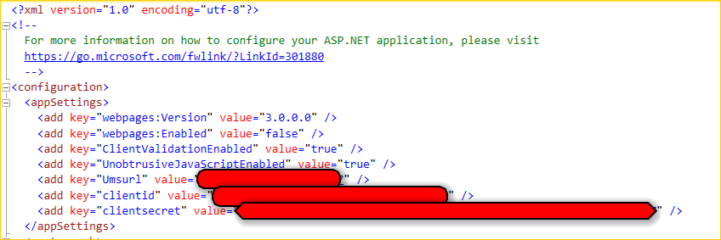

- From the required controller action we have to redirect to the authorization URL (WebConfigurationManager.AppSettings["Umsurl"] + "/oauth/v1/authorize") along with client_id, redirect_uri, response_type and client_secret as arguments as below,

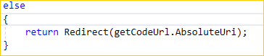

- Then the UMS page will be rendered and the authentication will be done and redirected back to the redirect_uri along with uniquely generated code.
- Once the code generated from UMS, we have to request for token by sending the properties as in the below link,
https://developer.okta.com/blog/2018/04/10/oauth-authorization-code-grant-type

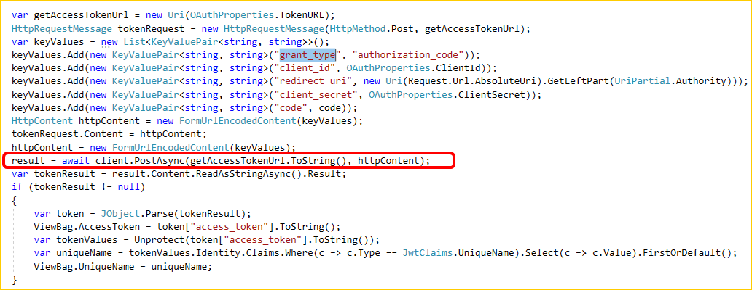

- Once the token will be received from the UMS, you can unprotect it and get the Claims as below to set the cookie/session from your end.
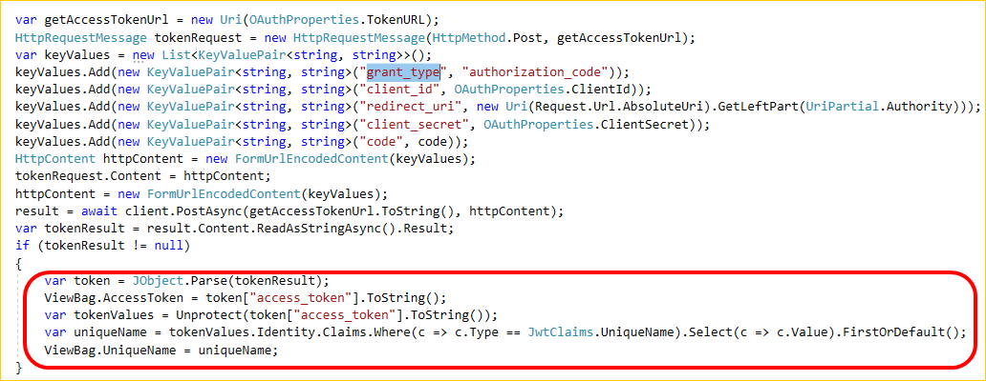

Note:
The “redirect_uri” must be similar to the registered application URL as below while sending for authorization and generating the token with UMS.
