Custom Processor

Perquisite
- Maven 3.3.x or later
- Java-8 or later

Creating maven archetype
Step 1: Create a directory where you want to create a custom processor project say E:\CustomProcessor
Step 2: Run the following command in command prompt on the created directory
mvn archetype:generate
Step 3: You will be asked for more parameters while generating archetype,
Choose a number or apply filter (format: [groupId:]artifactId, case sensitive contains): 990: nifi
Choose archetype:
1: remote -> org.apache.nifi:nifi-processor-bundle-archetype (-)
2: remote -> org.apache.nifi:nifi-service-bundle-archetype (-)
Choose a number or apply filter (format: [groupId:]artifactId, case sensitive contains): : 1
Choose org.apache.nifi:nifi-processor-bundle-archetype version:
1: 0.0.2-incubating
2: 0.1.0-incubating
3: 0.2.0-incubating
4: 0.2.1
5: 0.3.0
6: 0.4.0
7: 0.4.1
8: 0.5.0
9: 0.5.1
10: 0.6.0
11: 0.6.1
12: 0.7.0
13: 0.7.1
14: 0.7.2
15: 0.7.3
16: 0.7.4
17: 1.0.0-BETA
18: 1.0.0
19: 1.0.1
20: 1.1.0
21: 1.1.1
22: 1.1.2
23: 1.2.0
24: 1.3.0
Choose a number: 9: 21
Define value for property 'groupId': : org.apache.nifi
Define value for property 'artifactId': : convertcase
Define value for property 'version': 1.0-SNAPSHOT: : 1.1.1
Define value for property 'artifactBaseName': : custom
Define value for property 'package': org.apache.nifi.processors.custom: :
[INFO] Using property: nifiVersion = 1.1.1
Confirm properties configuration:
groupId: org.apache.nifi
artifactId: convertcase
version: 1.1.1
artifactBaseName: custom
package: org.apache.nifi.processors.custom
nifiVersion: 1.1.1
Y: : y
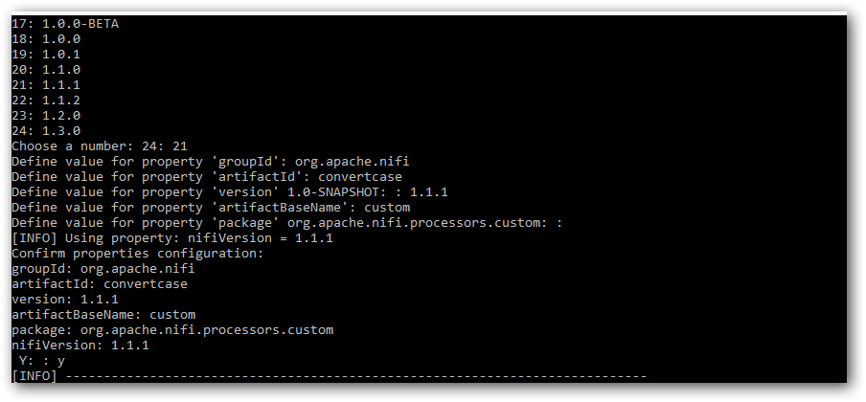
Step 4: Now you can find the project files under E:\CustomProcessor\convertcase
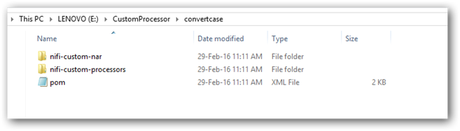
Step 5: Open the project in NetBeans or Eclipse
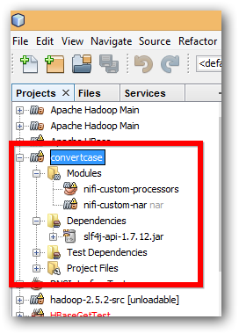
Step 6: Change Maven Home in NetBeans, Open tools->options->Java->Maven and do as following
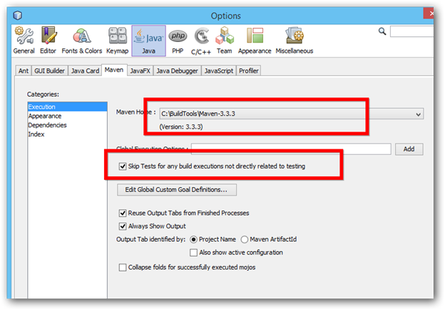
Step 7: You can see two modules in that,
a. nifi-custom-processors
b. nifi-custom-nar
Step 8: Open the nifi-custom-processors project
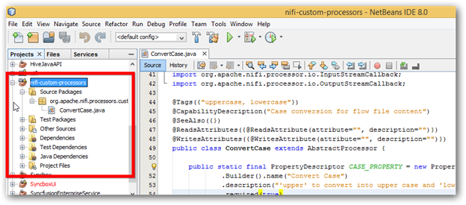
Step 9: You can find MyProcessor.java, Change the name as per your requirement.
Step 10: Change the same under nifi-custom-processors/Other Sources/src/main/resources/META-INF.services/org.apache.nifi.processor.Processor
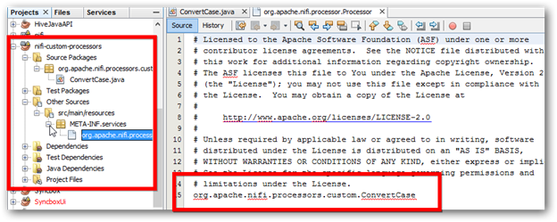
Step 11: Now build the project to generate the required jar and nar file
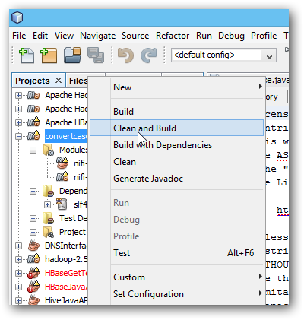
Step 12: Once you build successfully, you can find the nar file under E:\CustomProcessor\convertcase\nifi-custom-nar\target\ nifi-custom-nar-1.1.1.nar
Step 13: Copy the nar file into “/syncfusion_location/SDK/NIFI/lib” and restart the Data Integration service.

