Synchronization between two tables in different SQL servers.

Steps to load the template to Data Integration Platform
Step 1: Click on the templates from the graph work area to upload the data integration template.
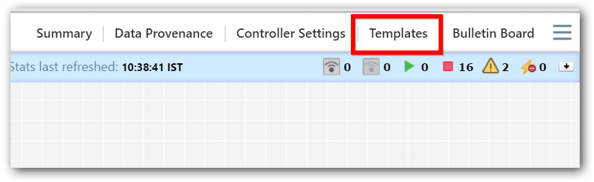
Step 2: In template dialog click on the browse button
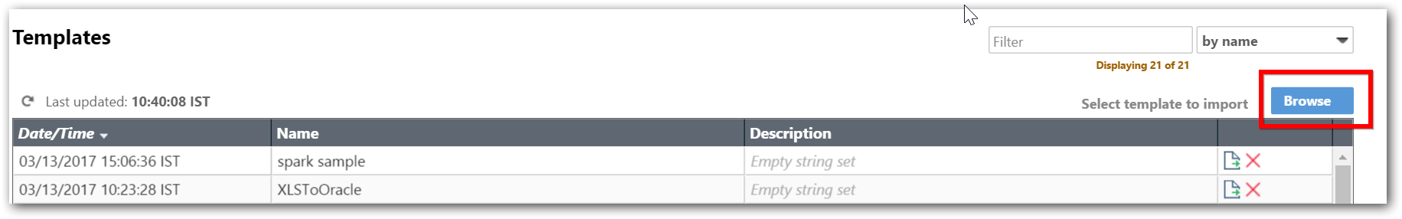
Step 3: Select the xml file and click on open button.
Step 4: Now click on import button and then close the dialog.
Step 5: We can find the list of sample’s details by drag and drop template icon in graph work area.
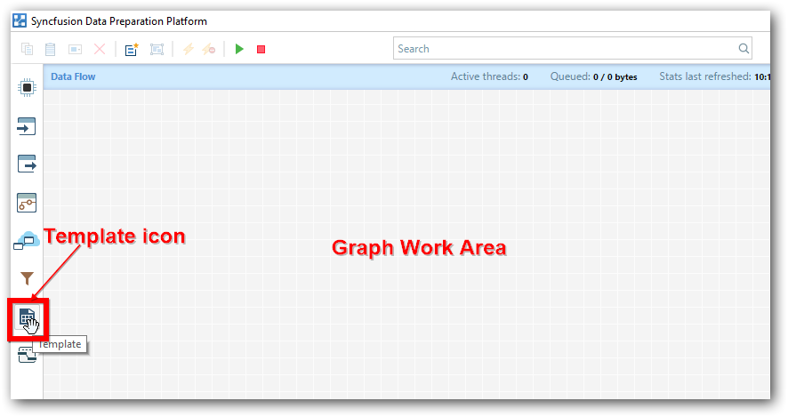
Step 6: List of sample’s, provided in data Integration.
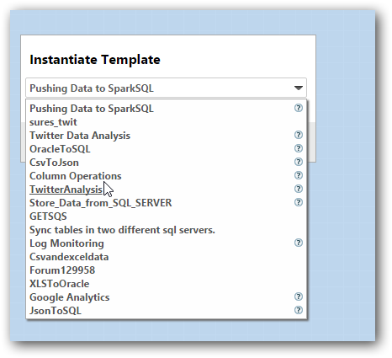
Step 7: Choose ‘Sync tables in two different sql servers’sample and click on ‘Add’ button.
Step 8: The group processor enabled on the work area.
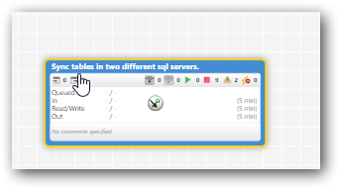
Step 9: Double click on the group processor to configure the processors.

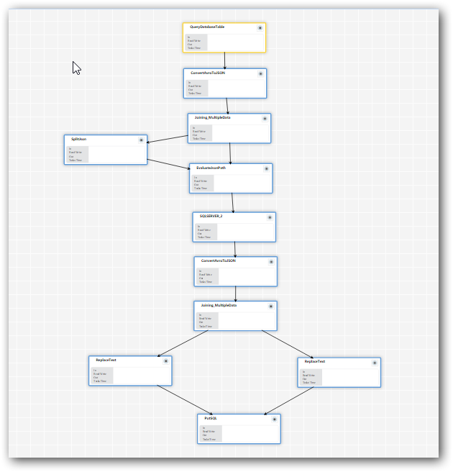

Steps to create the connection with SQL server.
After loading the Template in to the Data Integration Platform you need to create Connection with SQL server.
Note : You need to create two different connection for each server using the below step

Step 1 -
Go to Controller services in the Data Integration Platform.
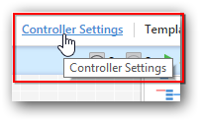

Step 2-
In the “Data Flow Settings”, Navigate to “Controller Services” tab.
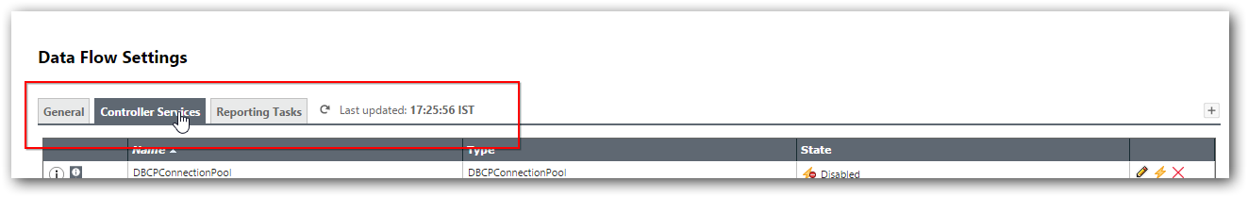

Step 3 -
Click on “+” icon to create new controller service.
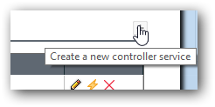

Step 4-
In Add controller service window, select “DBCPConnectionPool” and click add
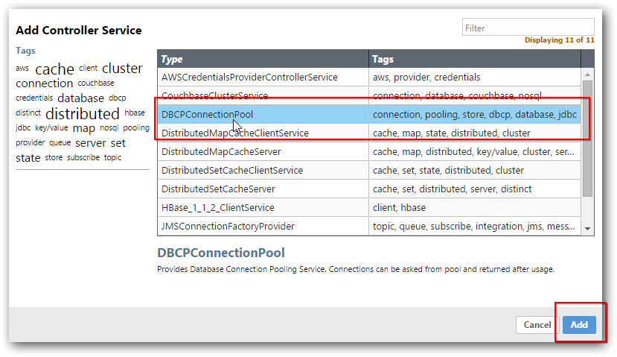

Step 5-
In that click on “EDIT” icon to configure the controller services.

Step 6:
In Configure Controller Service give the below details to connect with sql.
Field | Format | Example
Database Connection URL | Jdbc:sqlserver://<ipaddress>or<hostname>:<portno>;databse=<databasename> | jdbc:sqlserver://localhost:1433;database=demo
Database Driver Class Name | com.microsoft.sqlserver.jdbc.SQLServerDriver | com.microsoft.sqlserver.jdbc.SQLServerDriver
Database Drive Locations | file:///<Input Directory path for jar>  Note: Download the sqljdbc jar and give the input directory path for the jar.  Link to download - https://www.microsoft.com/en-in/download/details.aspx?id=11774 | file:///C:\Users\Desktop\sqljdbc4-3.0.jar
Database User | Data base user name | username
Password | Data base Password | xxxxx

Give the required details and click on apply.
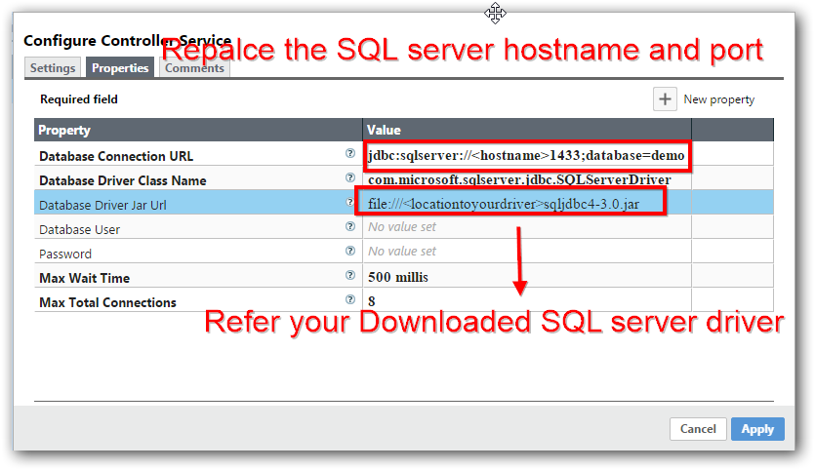

Step 7:
Click on enable symbol and click on the enable button from enable controller service dialog.
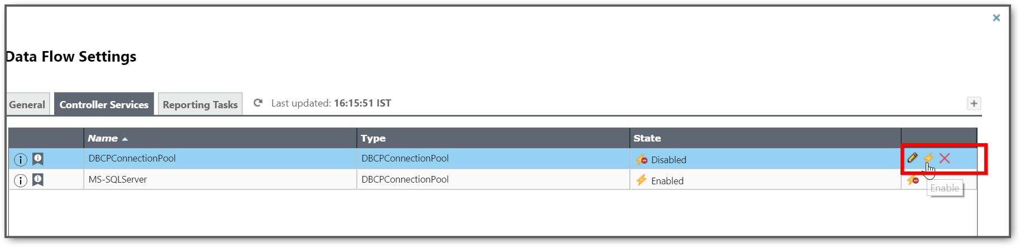
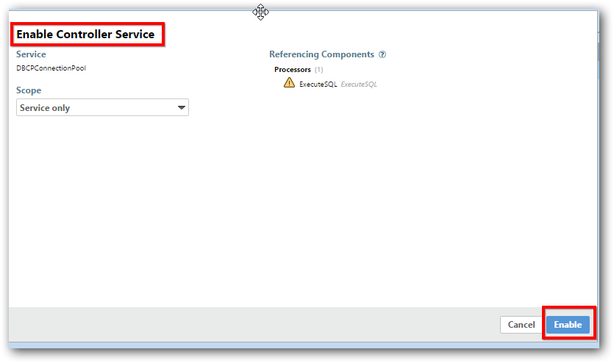

Step 8:
After enabling the services close the process group configuration dialog. Now the connection established with SQL server.
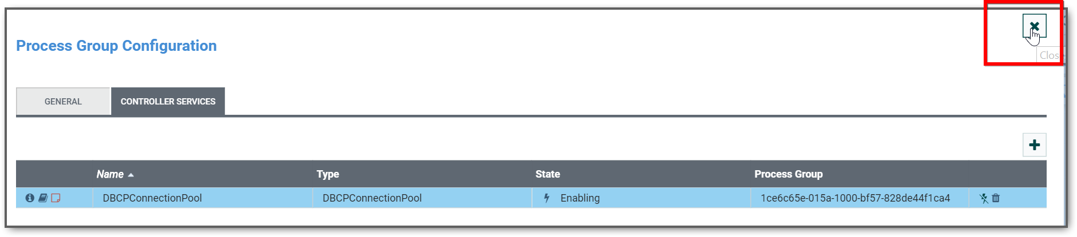

Step 9:
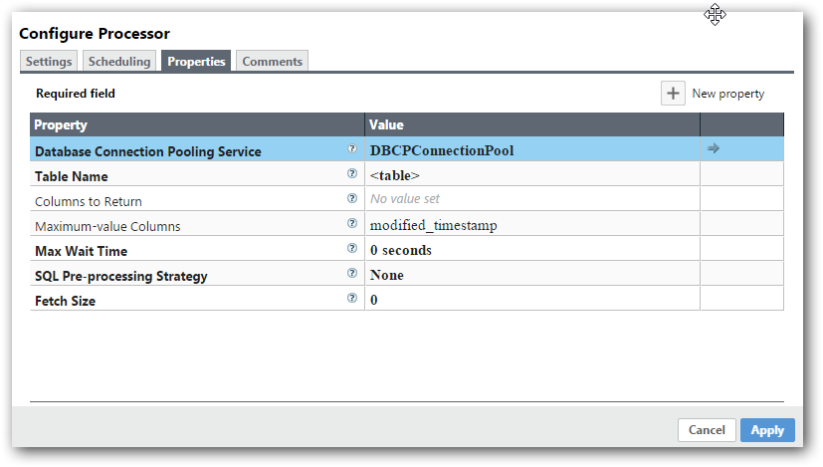

Description about the Workflow

QueryDatabaseTable
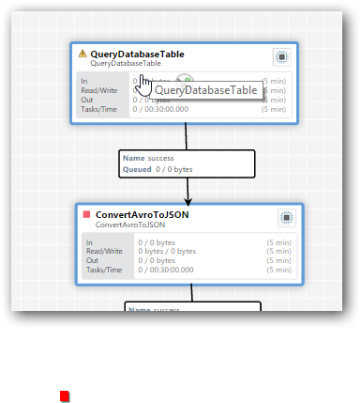

- Right click on the QueryDatabaseTable and configure the values.
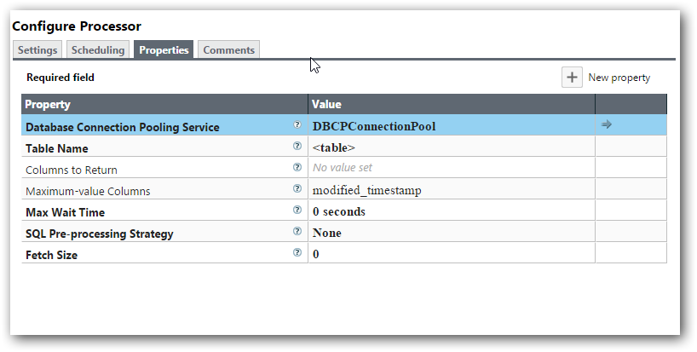
- Property | - Value
- Database Connection Pooling Service | - Created DBCP connection pool
- Table Name | - Your source table
- Maximum-value Columns | - modified_timestamp(lastupdate timestamp column)

- Scheduling-
- In the scheduling tab, we can configure the Scheduler of the workflow. In the template, we have configured interval of 30 secs.
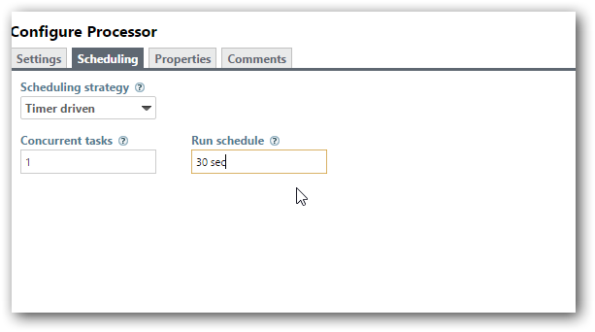

EvaluateJsonPath
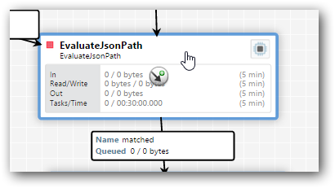
- Right click on the processor and navigate to properties.
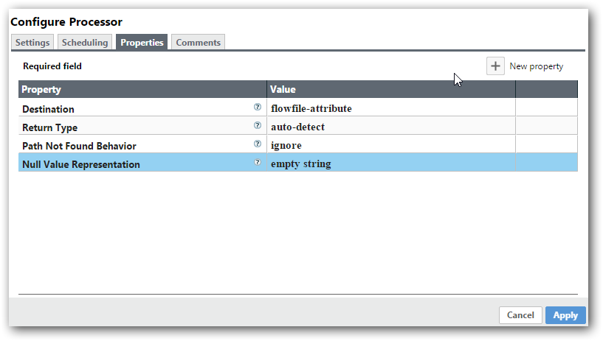
- In this you need to add the column name based on the tables. Let’s consider an example,
Table schema:
- 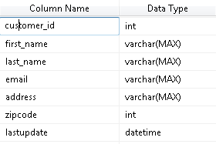
- You need to specify the new property values as below.
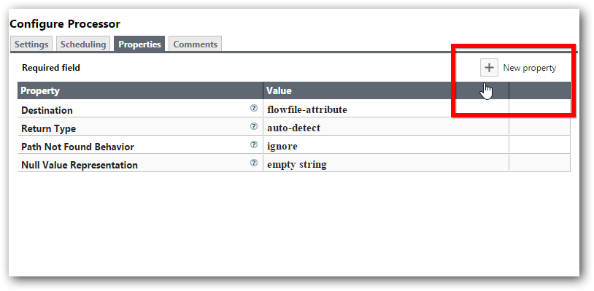
- Click on add New Property to add the attribute of the table schema.
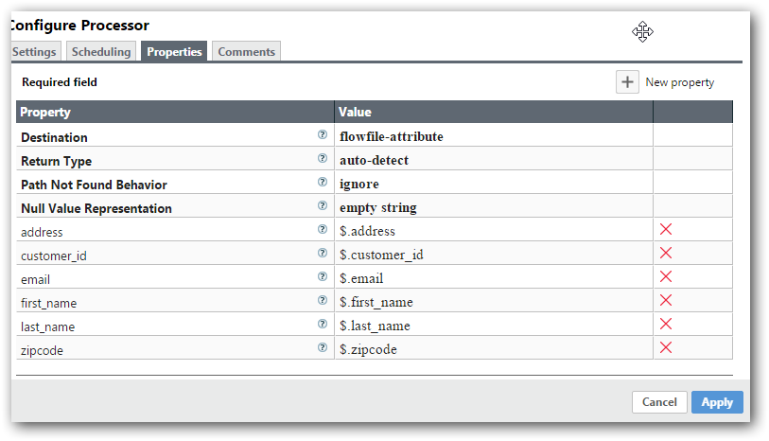
- Once added the properties the values in the Tables are moved the appropriate “AttributeNames”.

SQLSERVER_2
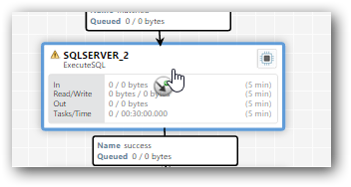
- In this processor, we need to check whether the record present in the Target table or not.
- Note: - Please select the “Database Connection Pooling Service” for the TARGET table
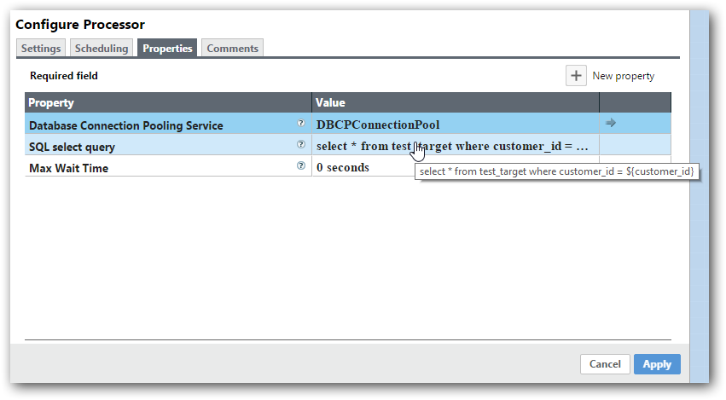

SQLSERVER 2_Insert
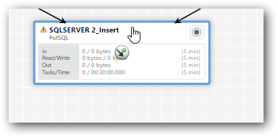
- You need to specify “Database Connection Pooling Service” for the TARGET table to Insert and update the data in source table.
