Setting position as absolute for div:

Code snippet:
<div style="position:absolute" >
<table width="100%" border="2">
<tr>
<td>1</td>
<td>2</td>
<td>3</td>
<td>4</td>
<td>5</td>
</tr>
<tr>
<td>1</td>
<td>2</td>
<td>3</td>
<td>4</td>
<td>5</td>
</tr>
<tr>
<td>1</td>
<td>2</td>
<td>3</td>
<td>4</td>
<td>5</td>
</tr>
<tr>
<td>1</td>
<td>2</td>
<td>3</td>
<td>4</td>
<td>5</td>
</tr>
<tr>
<td>1</td>
<td>2</td>
<td>3</td>
<td>4</td>
<td>5</td>
</tr>
<tr>
<td>1</td>
<td>2</td>
<td>3</td>
<td>4</td>
<td>5</td>
</tr>
</table>

Output:

Fig: Table set to its minimum width.

Not setting position for div:

Code snippet:
<div>
<table width="100%" border="2">
<tr>
<td>1</td>
<td>2</td>
<td>3</td>
<td>4</td>
<td>5</td>
</tr>
<tr>
<td>1</td>
<td>2</td>
<td>3</td>
<td>4</td>
<td>5</td>
</tr>
<tr>
<td>1</td>
<td>2</td>
<td>3</td>
<td>4</td>
<td>5</td>
</tr>
<tr>
<td>1</td>
<td>2</td>
<td>3</td>
<td>4</td>
<td>5</td>
</tr>
<tr>
<td>1</td>
<td>2</td>
<td>3</td>
<td>4</td>
<td>5</td>
</tr>
<tr>
<td>1</td>
<td>2</td>
<td>3</td>
<td>4</td>
<td>5</td>
</tr>
</table>

Output:
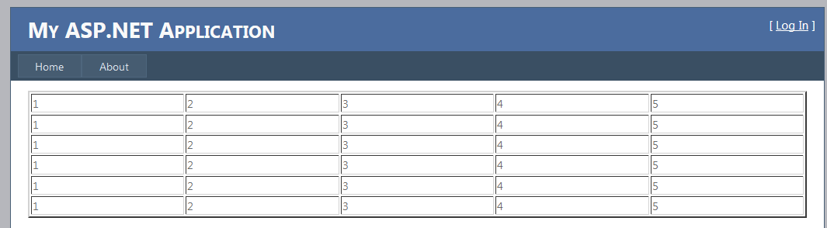
Fig: Table width with 100%.

We suggest you to set position as static/relative to resolve your reported issue or we suggest you to set width in pixels for the div.

